How to Use Beanstack

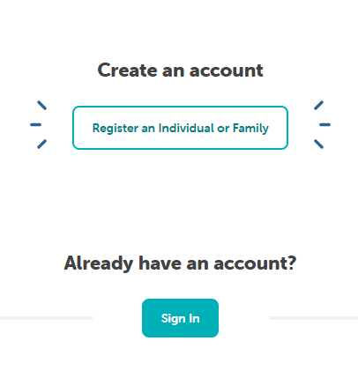
Beanstack Website Guide:

Registering for Beanstack
- Go to gppl.beanstack.org
- Select “Register an Individual or Family” if you do not have an account.
- There are two options; register yourself or register a child:
  - If you select register yourself, you can then register the rest of your household under one account for easier logging.
- Fill out your personal information, including either an email or a phone number.
  - You can add both, just make sure you add at least one so you can be notified if you win a prize.
- Once you fill out the required information, you can click “Next”.
- The option to add another adult will show up. If you do not want to add another adult, click no to prompt the option to add a child.
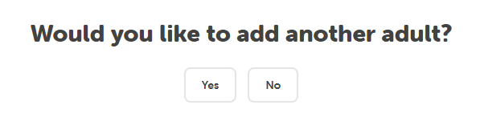
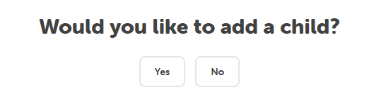
- If you would like to add a child, click yes and fill out all the required information.
- If there are multiple challenges for your age group, you can choose which ones you would like to participate in.
- To add more children, repeat the last two steps. If not, press no.

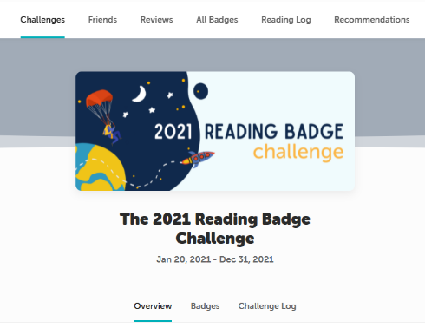
Challenges
- On the homepage, your challenges will be listed.
  - To see other profiles, click the name at the top right corner.
- To look at your challenges, click on the box on your home page. This will direct you to the challenge page.
  - From here, you can look at the overview, challenge and logging badges, earned badges, and the challenge log.
- Overview:
  - The overview will give you a description of the challenge.
- Challenge Badges:
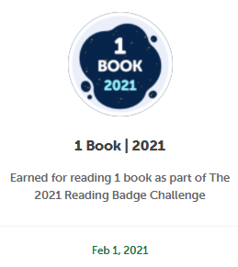
  - The challenge badges page will show you the badges you can earn for registering for and completing the challenge.
- Logging Badges:
  - The logging badges show you all the possible badges you can earn for logging your reading.
- Earned Badges:
  - This page displays all of the badges that you currently have.
- Challenge Log:
  - This page will keep track of all the books that you have logged and completed throughout the course of the challenge.

- Some challenges also offer rewards such as free books and other prizes. If you complete the challenge, you may be able to unlock a reward.
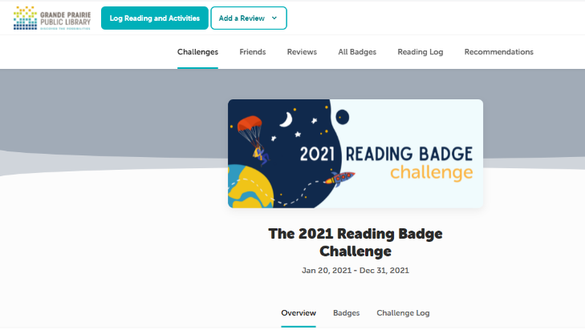

Logging Reading and Activities
- To log your reading, click the “Log Reading and Activities” tab at the top left of your screen.
  - If there is more than one person registered, you can select who you want to log for.
- Depending on the challenge, you can select to log books, days, or minutes of reading.
- Log Books:
  - Select the day you finished the book from the calendar.
  - Put the title and/or author of the book in the boxes.
  - Select the amount of times the book was read.
    - If it was read more than once, it will count as more than one book.
  - Click “Log”.
- Log Days:
  - Select any days that you have read on the calendar.
    - Days with green dots are ones that have been selected.
  - Put the title and/or author of the book in the boxes.
  - Click “Log”.
- Log Minutes:
  - Select the day(s) that you read.
  - Type in the time you spent reading
    - i.e. 35m for 35 minutes
  - Put the title and/or author.
  - Click “Log”.
- Remember that some challenges will only accept 1 type of logging, so make sure to do the right one(s). The mobile app will add days if you read minutes, etc. but the website does not yet have that functionality.

Other Tabs
- The other tabs near the top of the page include:
  - Challenges
    - This will take you to all the challenges that you are registered in
  - Friends
    - `This will take you to all the friends you have. If you have not added any yet, click “Add Friends”.
Code will be here
    - You can add friends by sharing your friend code or entering another friends code.
    - You can view your friends’ challenges, badges, and reading log.
  - Reviews
    - Under this tab, you can view your reviews and other people’s reviews.
    - You can also write your own reviews or create picture reviews from this tab. (see: writing a review section for help)
  - All Badges
    - This allows you to view all the badges and achievements you have earned from all the challenges in one place.
  - Reading Log
    - This shows you a summary of all the reading you have done.
      - It shows your streaks (how many continuous days of reading).
      - It shows the books, days, and time you have read.
  - Recommendations
    - This tab shows you any book lists that are recommended for you.
      - They can be based on age or genre.

Writing a Review
- Written Reviews:
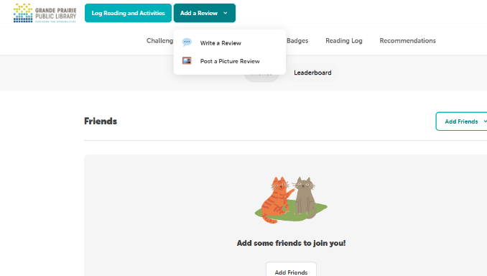
  - In the top-left corner, click add a review, then click written review
  - Select the person writing the review, then add the title, author, and your review.
    - You can also choose to log this book if you haven’t done so already
- Picture Reviews:
  - In the top-left corner, click add a review, then click picture review.
    - You can do things like drawings, Lego buildings, videos where you act out parts of a book, and more.
  - Once you have added your review, click “Save” for it to be submitted.

Beanstack App Guide:
- Download the app “Beanstack Tracker” from the App Store or Google Play Store
- When you open the app, there will be a screen about achieving reading goals. Click “Let’s Go!”
- It will then prompt you to choose an organization type. Be sure to choose “School, Library, or Bookstore”
  - From here, you can find Grande Prairie Public Library by typing that in the search bar.
  - If you already have an account, sign in. If not, click “Sign up”

Signing Up for the Beanstack App
- Pick a username and a password.
- If you would like, put your email in (recommended).
- Input your name
- If you would like, put your phone number in (recommended).
- From here, you can fill out your reader profile:
  - Give your first, last name, and age
  - Select your area (i.e. City of Grande Prairie)
  - Add a profile picture (optional)
  - Choose your grade level (“Babies and Toddlers” to “Adult”)
  - Choose your school (optional)
- Register for any challenges that you would like to partake in and press “Continue”
- If needed, add another reader and follow the same steps from above
- If you need to switch readers, click the top right corner, it should be your profile picture
  - This will give you the option to select which reader you want to log for.

Logging Your Reading
- Click the “+” in the bottom middle.
- Log either reading, an activity, or a review.
- Log Reading:
  - Choose the reader
  - Select: Scan the ISBN, search for the book, manually enter book info, or log without a title
  - You can either log past reading, start a reading session, or “quick log”
  - Start Reading session:
    - This will start a timer so you can see how long you’ve read for.
    - Once done, you can select whether you finished the book and then log it.
  - Log Past Reading:
    - Select the date of reading
    - Add the minutes you’ve read
    - Choose your start page and end page
      - i.e. Started on page 1, stopped reading on page 60
    - Select if you finished the book or not
  - Quick Log as Complete:
    - Clicking this option will just log the book as completed, no other information is needed.

The Home Page
- “My Stats” shows an overview of your reading.
  - The more information you log, the more stats you will have access to.
    - i.e. If you log pages and time read, you will be able to see your reading speed
- “Recent Titles” shows the recent books you have read
- “Current Challenges” shows the challenges you are in
- “My Badges” shows all the badges you have earned for completing tasks
- “My Reviews” shows the reviews that you have made

Log
- This will show:
  - Recent books
  - Completed books
  - Badges that you earn
  - Your Achievements
  - Your reading streaks
  - Your Reading Statistics

Discover
- This tab will show:
  - Available Challenges
  - Activities
  - Book Reviews from other people
  - Book lists (recommended books for you)

Community
- This shows your friends tab.
  - Add friends by clicking the button, and inputting a friend’s code (or sharing your own code)
  - Once you have a friend, you can see their achievements, badges, and reading history
  - The “Leaderboards” tab will show you who has read more out of all your friends.

Challenges
- If you click on a challenge, you will be able to see all the badges available, as well as your earned badges.

